**Data hiding and it’s importance**

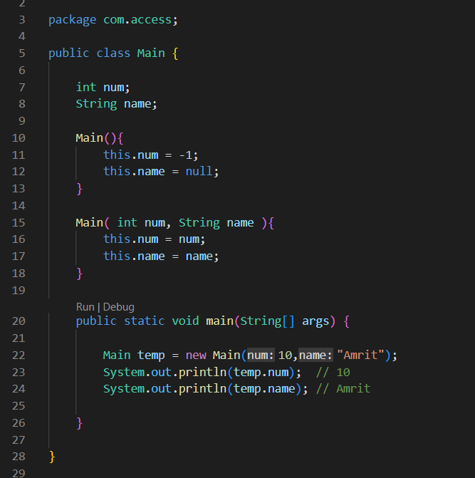

Here we have our internal data variables, num and name as public

So they are accessed from the outside the class via . operator as we are able to print them

But this is bad practice and really wrong

Since it doesn’t provide data security

So we restrict the access of the data variables of the class from outside the class and only allow them accessible via methods, this is called data hiding

Example

Even the Arraylist class has arrays of Integer type objects internally, but we are provided access to that array. We are just given the methods like .add( ) and others to work with it

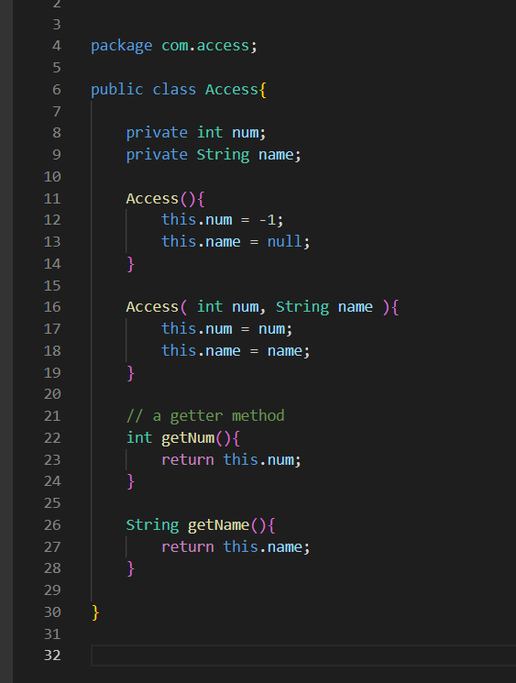

We make the internal data variables private for data security

We get those data via some methods known as getters

If we need to reinitialize those data variables we use methods generally knows as setters

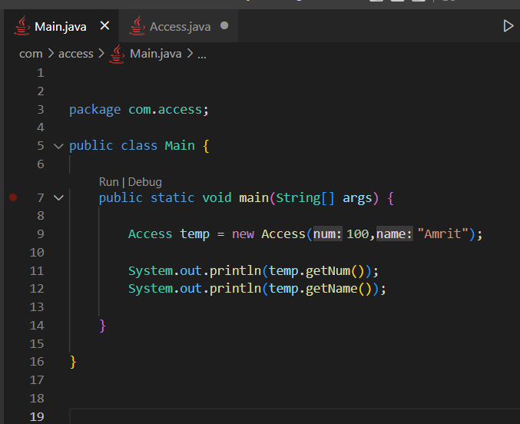

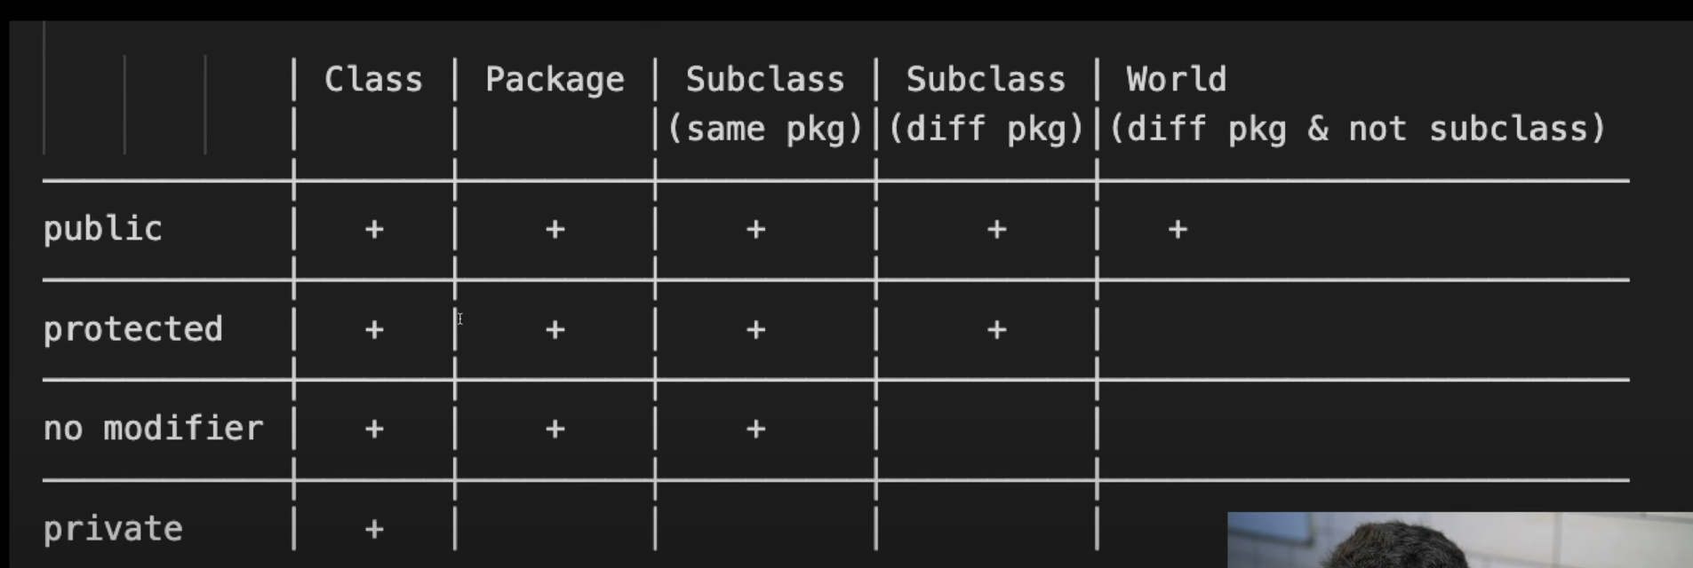

**no modifier**

It means when no any modifier is used

Here the data variables members are accessed everywhere within the same package but not within the different package

If we have to access everywhere even within the different package then we must mention public

**Protected**

Actually it was made for inheritance

The data members are accessed only within the child classes only

**Uses of access modifiers**

**Private :** For really sensitive data, when we do not want the data to be accessed from outside the current class. We will be making getters and setters for accessing these from outside the class

**Protected :** When we want to access the data only from the inherited classes

**No modifiers :** When we do not want our data to be accessed from the other packages then our current package

**Public :** When we want to access the data directly from everywhere